Lipoteichoic Acid (LTA)
Experimental Raman, Fragment-Level DFT, Literature and SERS Evidence Assessment

Executive Summary
This report assembles all verified Lipoteichoic Acid (LTA) Raman evidence currently available in the project — experimental powder Raman, fragment-level DFT calculations, literature comparison, and candidate SERS data with blank-substrate control — into a single evidence chain: DFT → powder Raman → literature → SERS → blank validation.
Headline result:
The strongest current LTA reference band is 1093.2 cm⁻¹. It is reproducibly observed in the powder Raman experiment (position std dev 1.95 cm⁻¹ across 12 spots), is consistent with the available fragment-level DFT calculation (GlcNAc fragment, Δ = 12.7 cm⁻¹), and lies within the literature-reported phosphodiester PO₂⁻ stretching region (1080–1095 cm⁻¹). A validated LTA-specific SERS signal has not yet been established for this or any other band.
Of the 7 experimental powder Raman peaks, 5 have a DFT fragment feature within ±15 cm⁻¹ (MAE 7.2 cm⁻¹, RMSE 8.0 cm⁻¹); 2 do not and are reported as unmatched, not forced. Fifteen candidate SERS spectra and 27 matched blank spectra are available; 6 of 15 detected SERS-candidate peaks coincide with the blank (substrate features) and 9 do not, but none of the 9 has undergone the pixel-level validation needed to call it an LTA signal. The one prior positive SERS claim from this dataset was already retracted by the project as a single-pixel artifact. No band currently achieves a three-way CONFIRMED status; the closest three-way overlap (1602 cm⁻¹) is explained by the blank substrate, not by LTA.

1. Objective
The objective of this work is to establish which LTA Raman bands are experimentally observable and reproducible, to determine how well those bands are supported by fragment-level DFT calculation and by existing literature, and to determine whether any of these bands can currently be detected using the project's SERS substrate once a blank-substrate control is applied. The report is deliberately conservative: a band is only described using the strongest label its evidence actually supports.

2. Experimental Powder Raman
Experimental conditions (from the raw data files): 784.92 nm laser, power level 20, 20 s integration time, 2 averages per spot, 12 measurement spots, acquired 2026-02-09 (20-04/20sec20power-variable location LTA/). Each spot spectrum was baseline-corrected (ALS), smoothed (Savitzky-Golay), and area-normalized; the 12 spectra were then averaged.
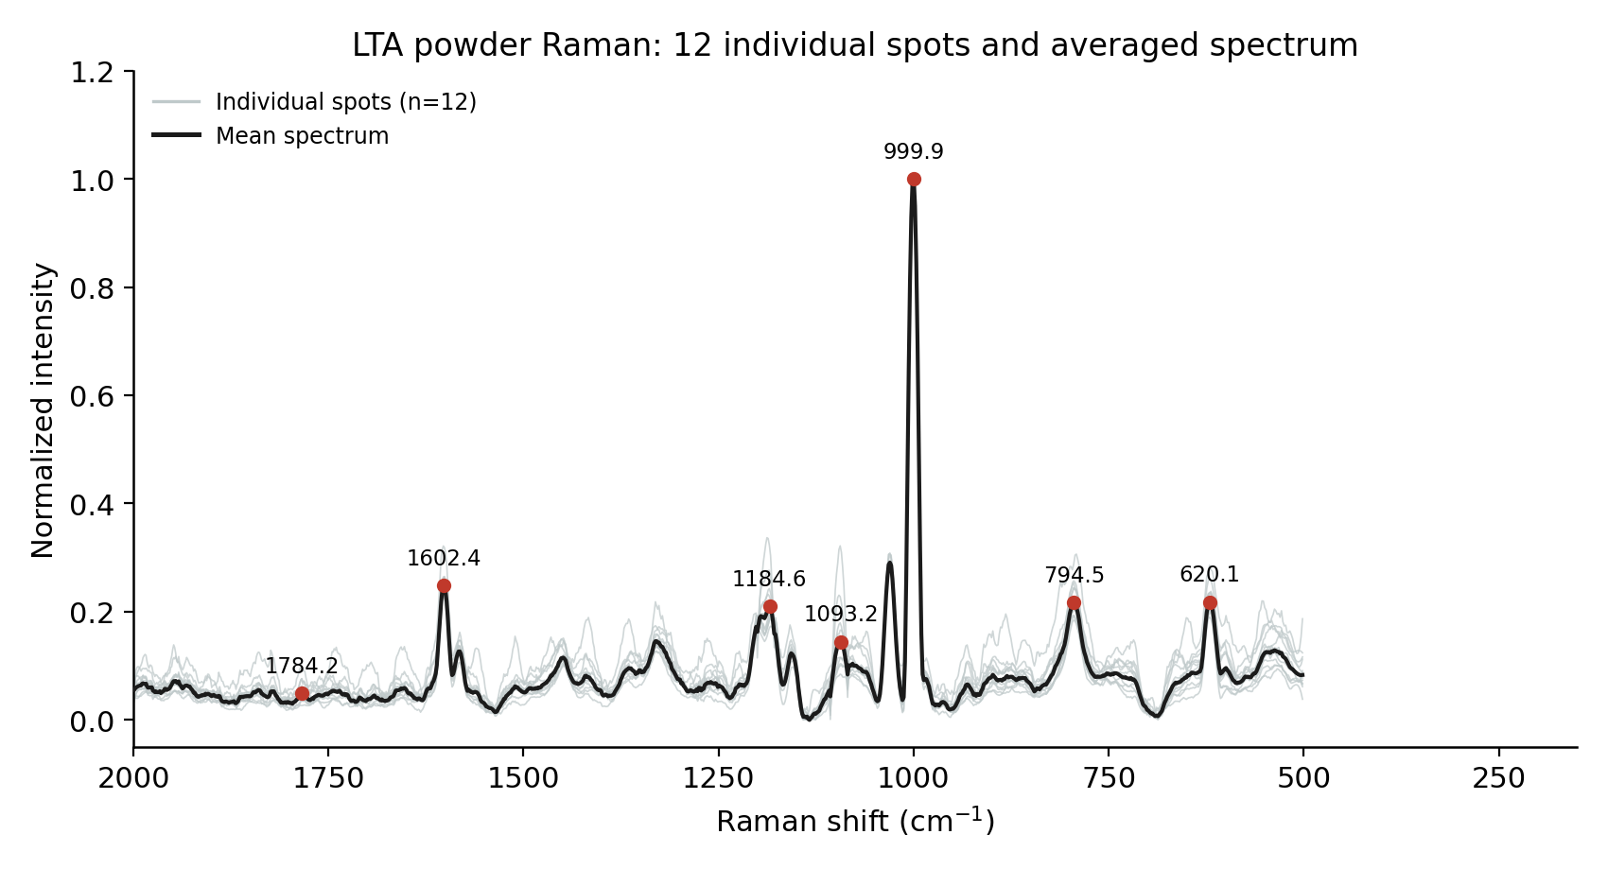
Figure 1. LTA powder Raman: all 12 individual spot spectra (light gray) and the averaged spectrum (black), with the 7 characteristic peaks marked.
Experimental peak (cm⁻¹) | Mean position (cm⁻¹) | SD (cm⁻¹) | Detection frequency | Intensity CV | Interpretation
620.1 | 620.1 | 0.83 | 12/12 | 10.68% | Reproducible position; intensity stable
794.5 | 794.5 | 0.94 | 12/12 | 7.79% | Reproducible position; intensity stable
999.9 | 999.9 | 0.45 | 12/12 | 19.88% | Most reproducible position; intensity variable
1093.2 | 1093.2 | 1.95 | 11/12 | 37.52% | Reproducible position; intensity highly variable
1184.6 | 1184.6 | 1.72 | 11/12 | 13.20% | Reproducible position; intensity moderately variable
1602.4 | 1602.4 | 0.61 | 12/12 | 13.24% | Reproducible position; intensity moderately variable
1784.2 | 1784.2 | 0.00 | 6/12 | 14.86% | Weakest band — detected in only half the spots
Peak positions are highly reproducible across all 7 bands (standard deviation ≤ 1.95 cm⁻¹). Intensity reproducibility is weaker: three of the seven peaks (999.9, 1093.2, 1784.2 cm⁻¹) exceed 15% coefficient of variation, and 1784.2 cm⁻¹ was detected in only 6 of the 12 spots — the least reproducible band overall. Position agreement should be trusted more than intensity agreement throughout the rest of this report.

3. DFT Simulation
Three LTA-related building blocks were successfully calculated at the B3LYP/6-31G(d) level (Gaussian 09, ×0.96 scaling factor): glycerol-phosphate, D-alanine, and N-acetyl-D-glucosamine (GlcNAc). These are isolated chemical fragments of LTA, not the intact molecule.
The intact, phosphodiester-linked, lipid-anchored LTA polymer was NOT successfully modeled. A whole-molecule Gaussian calculation was attempted (20-04/molecules/LTA Final/LTA.LOG) but terminated with an error before reaching the frequency/Raman-activity stage — no usable output was produced. All DFT comparisons in this report are therefore fragment-level only.
Each fragment's output file was checked for point spacing: all three (444–500 points, uniform 8–9 cm⁻¹ step) are interpolated, broadened curves, not discrete lists of calculated vibrational modes — a genuine frequency calculation produces one entry per normal mode at irregular, molecule-specific positions. No mode number or symmetry label is reported anywhere in this document because none exists in the available output.
Because of both limitations above, the DFT analysis in this report is a fragment-level qualitative consistency check only. It is not, and is not presented as, a complete DFT model of intact LTA.

4. Experimental vs. DFT Comparison
DFT candidate peak positions were extracted as local maxima of the three broadened fragment curves, scaled ×0.96, restricted to 200–1900 cm⁻¹ (75 candidates total). Each of the 7 experimental peaks was matched to its nearest DFT candidate using a fixed ±15 cm⁻¹ criterion, set before matching was performed.
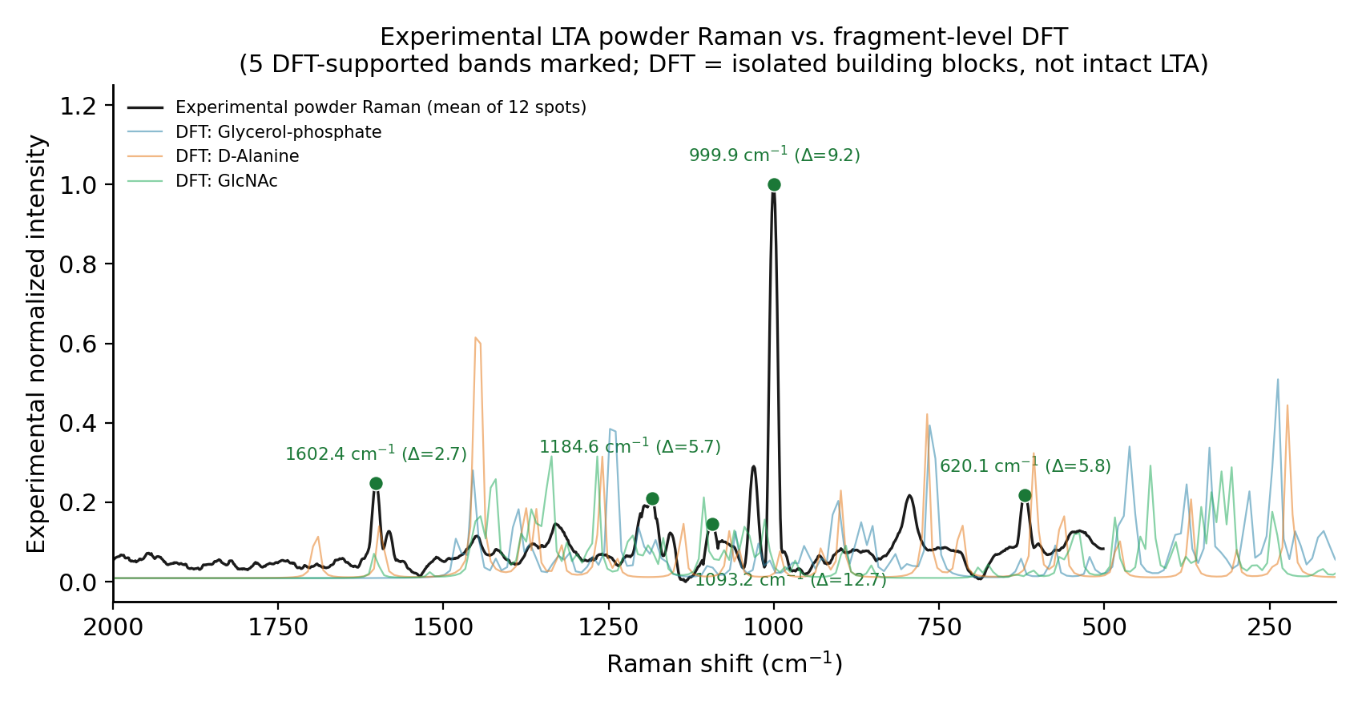
Figure 2. Experimental LTA powder Raman vs. fragment-level DFT curves; only the 5 DFT-supported bands are marked.
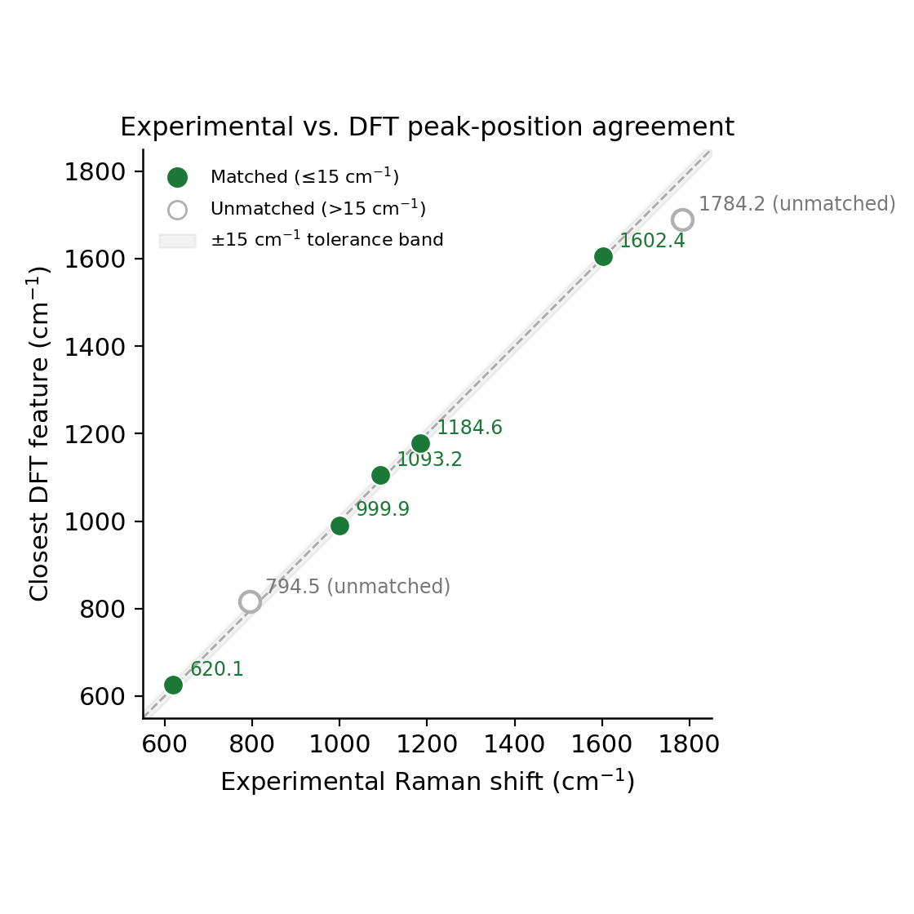
Figure 3. Experimental vs. DFT peak-position agreement, with a y = x reference line and ±15 cm⁻¹ tolerance band. Matched (filled) and unmatched (open) bands are distinguished.
Experimental peak (cm⁻¹) | Closest DFT feature (cm⁻¹) | Δ (cm⁻¹) | DFT fragment | Assignment / interpretation | Confidence
620.1 | 625.9 | 5.8 | Glycerol-phosphate | Qualitative positional consistency with fragment | Low–Moderate
794.5 | — (no match ≤15 cm⁻¹) | — | Glycerol-phosphate | Not determinable — no DFT candidate within tolerance | Unconfirmed
999.9 | 990.7 | 9.2 | D-Alanine | Qualitative positional consistency with fragment | Low–Moderate
1093.2 | 1105.9 | 12.7 | GlcNAc (N-acetyl-D-glucosamine) | Qualitative positional consistency with fragment | Low–Moderate
1184.6 | 1178.9 | 5.7 | Glycerol-phosphate | Qualitative positional consistency with fragment | Low–Moderate
1602.4 | 1605.1 | 2.7 | GlcNAc (N-acetyl-D-glucosamine) | Qualitative positional consistency with fragment | Low–Moderate
1784.2 | — (no match ≤15 cm⁻¹) | — | D-Alanine | Not determinable — no DFT candidate within tolerance | Unconfirmed
Result: 5/7 matched within ±15 cm⁻¹. MAE = 7.2 cm⁻¹, RMSE = 8 cm⁻¹ (matched bands only). One-to-one check: 0 duplicate DFT assignments.
794.5 and 1784.2 cm⁻¹ are reported as unmatched. No DFT candidate has been substituted for either, and the five matches are not presented as proof of the intact LTA structure — they indicate qualitative consistency with LTA's known chemical building blocks only.

5. Literature Comparison
Literature bands are drawn from the evidence-tier table already compiled in the project's reference document (Experiment_Plan_LTA.docx).
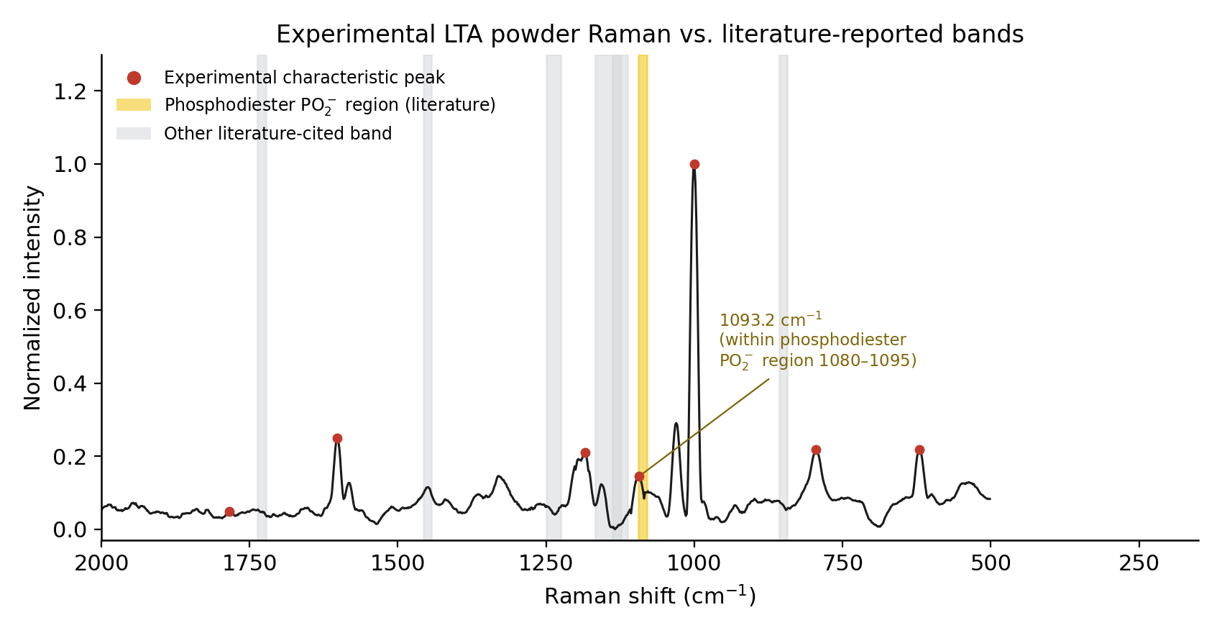
Figure 4. Experimental LTA powder Raman vs. literature-reported bands; the 1080–1095 cm⁻¹ phosphodiester PO₂⁻ region is highlighted together with the experimental 1093.2 cm⁻¹ band.
Experimental LTA peak (cm⁻¹) | Literature region (cm⁻¹) | Difference (cm⁻¹) | Literature assignment | Evidence level
1093.2 | 1080-1095 | 5.7 | PO2- symmetric stretch (phosphodiester backbone) | LIT-CONFIRMED
— (no experimental peak within tolerance) | 1225-1250 | — | (as stated in source document) | PREDICTION
— (no experimental peak within tolerance) | 1450 | — | (as stated in source document) | LIT-MENTIONED
— (no experimental peak within tolerance) | 1131 | — | (as stated in source document) | (tier as stated)
— (no experimental peak within tolerance) | 850 | — | (as stated in source document) | (tier as stated)
— (no experimental peak within tolerance) | ~1730 | — | (as stated in source document) | PREDICTION
— (no experimental peak within tolerance) | 1160, 1120 | — | (as stated in source document) | LIT-MENTIONED
The experimental 1093.2 cm⁻¹ band falls directly within the 1080–1095 cm⁻¹ phosphodiester PO₂⁻ region — the strongest literature convergence point identified in this project.
The project documentation does not establish, for each cited reference, whether the underlying spectrum was measured on purified LTA or on whole bacterial cells. This is reported as an open point, not resolved by assumption, and absolute LTA specificity should not be claimed from literature alone.

6. SERS Analysis
15 candidate LTA SERS spectra (14-08-26-lta-2m-etched/, Ag/black-Si MACE-etched substrate, 785 nm) and 27 matched blank-substrate spectra (raw-si-2m-etched/, same day, identical calibration/laser settings) are available.
A previous positive claim from this exact dataset (an apparent 1095 cm⁻¹ LTA detection) was investigated at the pixel level by the project and retracted as a single-pixel artifact. That retraction stands as the authoritative prior result for this dataset.
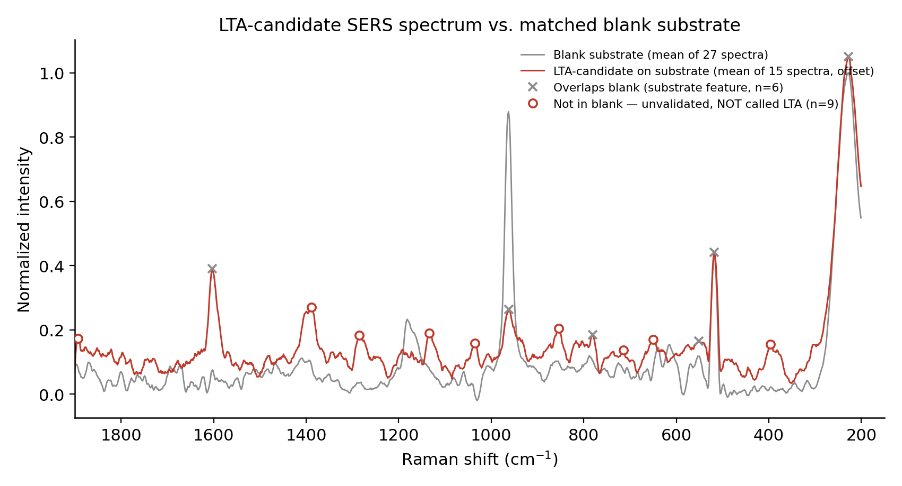
Figure 5. Averaged LTA-candidate SERS spectrum vs. averaged matched blank spectrum. Peaks overlapping the blank (n=6) and peaks not in the blank (n=9, unvalidated) are marked separately.
Candidate peak (cm⁻¹) | Nearest blank peak (cm⁻¹) | Δ (cm⁻¹) | Classification
227.6 | 227.6 | 0 | Overlaps blank
396 | 517.8 | 121.7 | Not in blank (unvalidated)
517.8 | 517.8 | 0 | Overlaps blank
551.7 | 553.5 | 1.8 | Overlaps blank
650.5 | 615.4 | 35 | Not in blank (unvalidated)
714.6 | 788 | 73.4 | Not in blank (unvalidated)
781.2 | 788 | 6.8 | Overlaps blank
853.6 | 788 | 65.6 | Not in blank (unvalidated)
962.5 | 962.5 | 0 | Overlaps blank
1035.2 | 962.5 | 72.7 | Not in blank (unvalidated)
1133.5 | 1181.8 | 48.3 | Not in blank (unvalidated)
1285.8 | 1181.8 | 104.1 | Not in blank (unvalidated)
1388.9 | 1409.5 | 20.6 | Not in blank (unvalidated)
1602.7 | 1602.7 | 0 | Overlaps blank
1893.2 | 1800.2 | 93 | Not in blank (unvalidated)
Of the 15 detected candidate peaks, 6 coincide with a blank-substrate peak within 15 cm⁻¹ and are treated as substrate features, not LTA signal. The remaining 9 do not coincide with the blank, but have not yet undergone pixel-level validation — the same level of scrutiny that identified the earlier single-pixel artifact in this dataset. None of the 9 is called a confirmed LTA SERS signal in this report.

7. DFT → Powder → SERS Comparison
Each of the 7 powder characteristic peaks is followed through DFT, powder Raman, SERS, and blank control, focusing especially on the two strongest candidate regions: 1093.2 cm⁻¹ (literature + DFT convergence) and 1602.4 cm⁻¹ (close powder/SERS overlap).
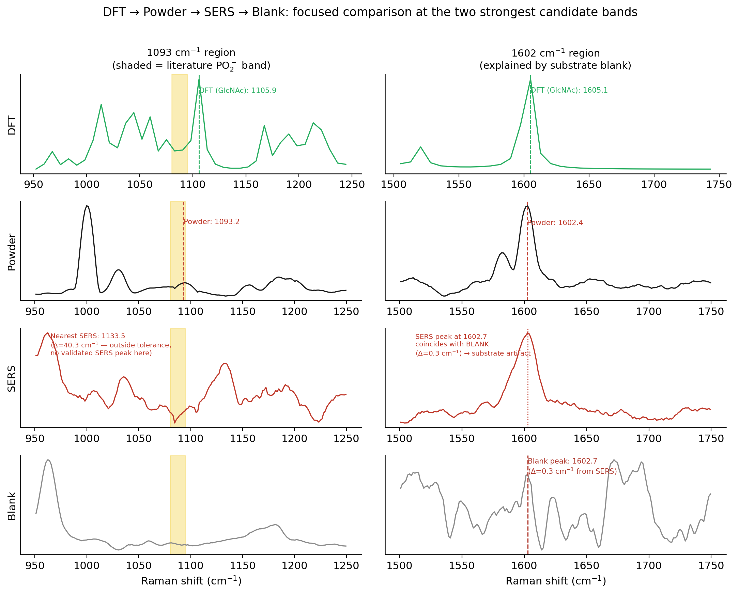
Figure 6. Focused DFT → Powder → SERS → Blank comparison at 1093 cm⁻¹ (no SERS peak within tolerance) and 1602 cm⁻¹ (SERS peak present, but explained by the blank).
Band (cm⁻¹) | DFT support | Powder Raman | SERS candidate | Blank control | Final status
620.1 | Yes (Δ=5.8 cm⁻¹) | Reproducible (Section 2) | None within tolerance | Not testable | UNCONFIRMED
794.5 | No | Reproducible (Section 2) | Peak at 781.2 cm⁻¹ (Δ=13.3) | Present in blank | UNCONFIRMED
999.9 | Yes (Δ=9.2 cm⁻¹) | Reproducible (Section 2) | None within tolerance | Not testable | UNCONFIRMED
1093.2 | Yes (Δ=12.7 cm⁻¹) | Reproducible (Section 2) | None within tolerance | Not testable | STRONG CANDIDATE
1184.6 | Yes (Δ=5.7 cm⁻¹) | Reproducible (Section 2) | None within tolerance | Not testable | UNCONFIRMED
1602.4 | Yes (Δ=2.7 cm⁻¹) | Reproducible (Section 2) | Peak at 1602.7 cm⁻¹ (Δ=0.3) | Present in blank | SUBSTRATE ARTIFACT
1784.2 | No | Reproducible (Section 2) | None within tolerance | Not testable | NOT DETECTED
Tally: CONFIRMED = 0, STRONG CANDIDATE = 1, UNCONFIRMED = 4, SUBSTRATE ARTIFACT = 1, NOT DETECTED = 1.
No band is classified CONFIRMED. 1093.2 cm⁻¹ is the only STRONG CANDIDATE (DFT + powder + literature converge, but no SERS peak exists within tolerance at this position). 1602.4 cm⁻¹ is classified SUBSTRATE ARTIFACT because its close SERS/powder overlap is explained by an identical blank-substrate peak (Δ=0.3 cm⁻¹) — it must not be read as an LTA detection.

8. Key Result
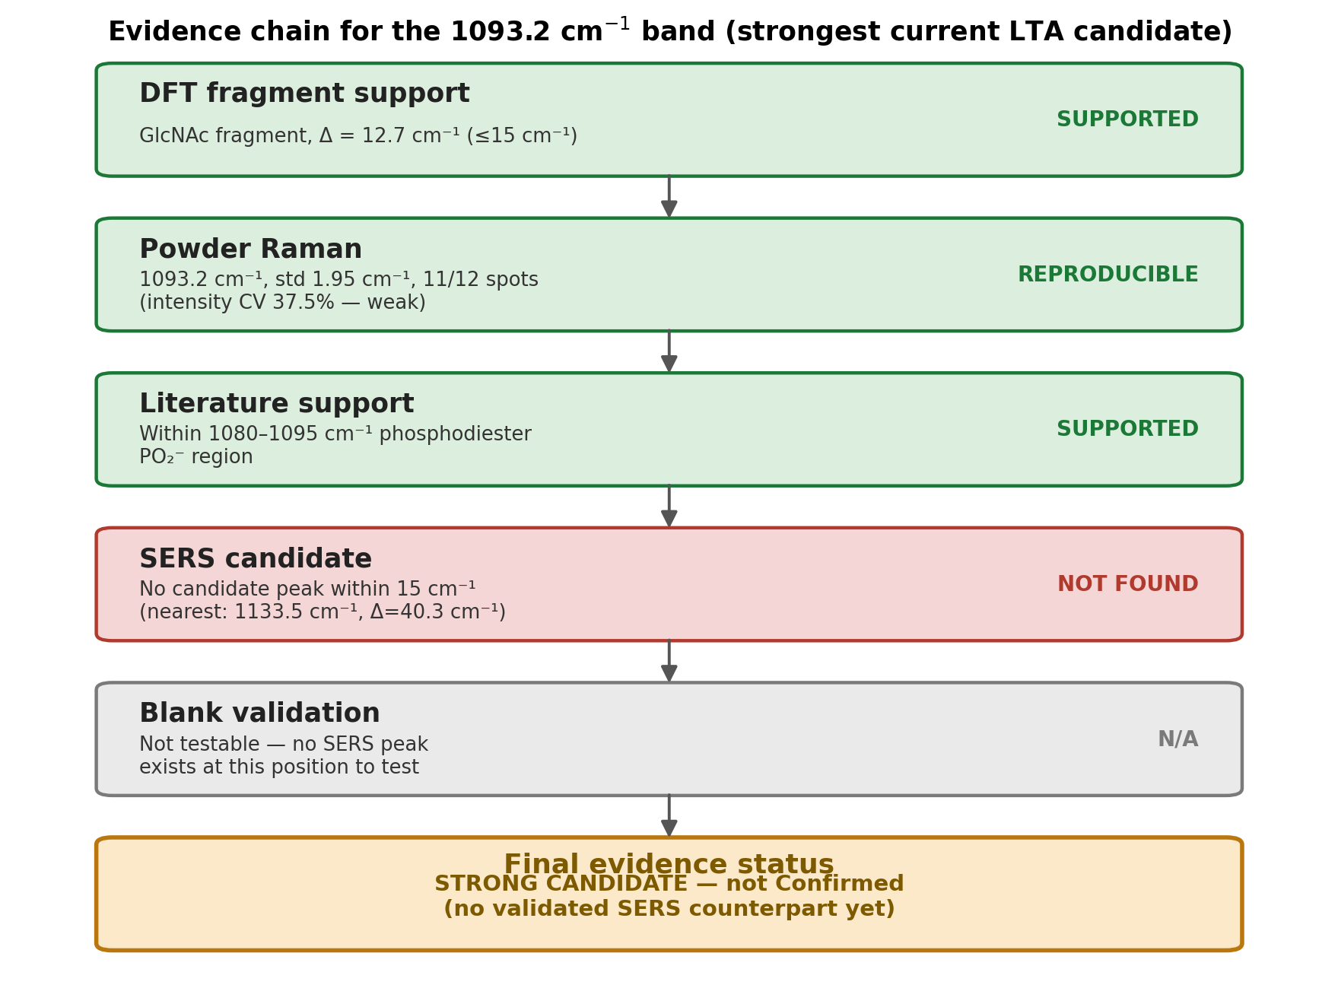
Figure 7. Evidence chain for the 1093.2 cm⁻¹ band, the strongest currently supported LTA reference band.
The strongest current LTA reference band is 1093.2 cm⁻¹ because it is reproducibly observed in the powder Raman experiment, is consistent with the available fragment-level DFT calculation, and lies within the literature-reported phosphodiester PO₂⁻ stretching region. However, a validated LTA-specific SERS signal has not yet been established.

9. Limitations
- An intact LTA DFT model is not available; only three isolated building-block fragments were successfully calculated, and agreement with experiment reflects consistency with LTA's chemical components, not confirmation of the assembled polymer.
- The available DFT outputs are interpolated/broadened curves rather than complete discrete vibrational-mode lists, so DFT peak positions used here are local maxima of those curves, not raw calculated mode frequencies with symmetry labels.
- Literature sample identity (purified LTA vs. whole bacterial cells) is not always clear in the project's own reference documentation and was not independently re-verified against original sources within this review.
- SERS candidate peaks not overlapping the blank (9 of 15) require pixel-level validation before any can be called a genuine LTA signal — this project has already found one such artifact in this same dataset.
- Blank-substrate interference is real and material: at least 6 of 15 candidate SERS peaks, including the previously-claimed 1602 cm⁻¹ feature, are explained by the substrate rather than by LTA.
- No confirmed three-way (DFT + powder + SERS) match currently exists for any band.

10. Next Experiment
- Use 1093 cm⁻¹ as the primary SERS target, given its convergent powder/DFT/literature support.
- Also monitor the other reproducible powder Raman bands (620.1, 999.9, 1184.6, 1602.4 cm⁻¹) rather than focusing exclusively on one band.
- Acquire multiple independent LTA SERS measurements (new sample preparation, new substrate batch).
- Acquire matched blank-substrate measurements under identical conditions for every new SERS batch.
- Perform pixel-level / spot-level reproducibility analysis on any candidate SERS peak before reporting it as positive.
- Compare SERS peaks against powder Raman, DFT, and literature simultaneously, not against any single source alone.
- Only call a band LTA-associated after it survives blank-substrate control and reproducibility testing across independent measurements.

